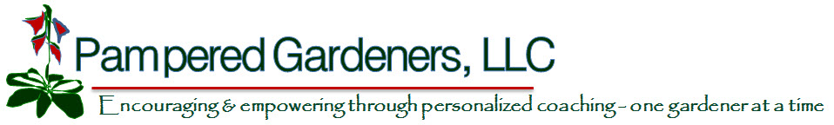

Pretty Outdoor Container Gardens for Fall Pam Brown, Pampered Gardeners, LLC

Container gardening is a very popular gardening trend. Mixed plantings in decorative pots can create a wonderful focal point in the landscape or on the patio. Containers full of flowers just seem to grow better during our cooler fall weather.

- Choose the pot first. Large pots can produce a very dramatic effect, but do consider the final weight of the pot. You may want to provide a plant stand with casters under large pots to make moving easier if necessary. Shallow pots are hard to maintain due to the insufficient rooting depth, unless you are planting a cactus garden. Drainage is very important, so be certain that the pot has adequate drainage holes in the bottom. If the holes are large, cover them with some pieces of broken clay pots or a piece of window screening.

- Choose a potting mix that is light for the size of the bag. One with perlite, peat moss and milled bark will provide good drainage. Do not be tempted to use the soil from your garden as it will be too heavy and can possibly infect your plants with soil borne diseases and pests. Using a manufactured potting soil instead of soil from your landscape will help avoid these problems. Also do not purchase top soil or garden soil for containers. It will hold too much water and plant roots may rot.

- Design your pot. A good combination is a trio of different plants; a thriller, filler, and a spiller. The thriller is a tall accent plant, fillers are mounding plants and spillers are trailing plants. You may need more than three plants if it is a large pot. Normally you would want to stick with one tall accent plant and add multiples of the mounding and/or trailing plants. Match plants that have similar growing requirements: light, temperature, water, fertilizer and growth rate. Choose all of your plants at the nursery or garden center where you can see them together. Be bold with color. Include plants with contrasting foliage, foliage shapes, flower sizes and colors. Keep your chosen pot in mind - dramatic pots need simple arrangements and vice versa.

- Plant the container. Fill the pot a little more than half way with potting soil and then begin placing the plants. You will want the soil to be about 1 – 2 inches below the rim of the pot when you are finished planting to allow space for watering. As you remove each plant from its pot, loosen the roots a little so that they will grow out into the potting soil. If you want a very densely planted container, soak the root ball of each plant so that you can squeeze it down to about one half the original size allowing for additional plants in the container. Be careful to keep each root ball level with the final top of the potting soil. Water well as you plant to settle the soil around each plant.

- Fertilize. Container plants need plenty of fertilizer due to reduced rooting growing space. Apply a balanced slow release fertilizer according to label directions, mixing it in as you complete your planting. Use a good quality fertilizer like Dynamite, Osmocote or Nutricote. In addition, water monthly with a water soluble fertilizer for an extra boost. Annual flowers need plenty of fertilizer to continue looking good, so apply the same balanced fertilizer to your pot again in mid January.

- Don’t forget to water. Under or over watering are the most common causes for the death of plants in containers. Containers can dry out quickly since fall and winter is usually quite dry here in Central Florida. Give your container water when the top one inch of the soil feels dry. Unglazed pottery may need water daily while it is still warm. Water until you see water coming out of the bottom of the container.

- Scout for pests often. We usually have fewer pests in the fall and winter, but be diligent. Look at your plants and treat as soon as you see pests. Neem oil is a great all around organic pesticide for things like mealy bugs, white flies, aphids and fungus. A spray containing Bt is good for caterpillars and is also environmentally friendly. Slugs and snails can ruin the looks of leaves very quickly. Choose a bait that consists of Iron Phosphate and add some to each container. This pesticide is pet and child friendly.

- Deadhead flowers frequently and prune lightly to keep everything in shape. Your creation should last until spring if we have a mild winter or if you have chosen cold hardy plants.

